The ChassisSim Tutorial

Introduction

The purpose of this document is to work you through a step by step process about how to create a ChassisSim model from data and a setup sheet.

This document will cover model creation, setting up a monster file and then using this to create an initial model you can use for lap time simulation. You can always return to this document as a road map if you get lost creating your own models.

This tutorial will be based on a twin shock F3 car run around the Zandvoort track in the Netherlands.

A note on the files supplied

In the folder C:\ChassisSim Technologies\CSim_v_no\help\ChassisSim Tutorial you will find all the files necessary to complete this tutorial. In particular you will find a completed car file and monster file. Feel free to use these as a reference for this tutorial or as a fall back if you get lost.

Also feel free to use this as an example to work through the other quick start guides in the help directory.

Step – 1 – Setup the ChassisSim directories.

Our first step is to setup the ChassisSim environment. Go to the ChassisSim folder and open to the help directory. In this folder you will find a directory called ChassisSim Tutorial. Open this folder and select the following files as illustrated,

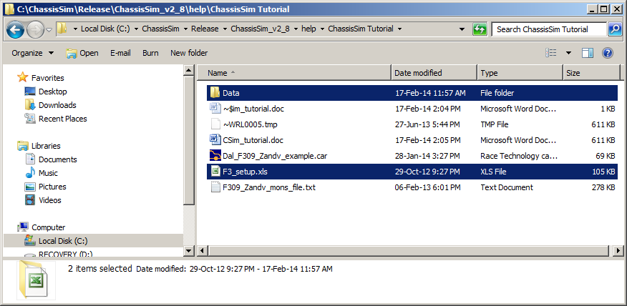

Copy these files.

The next step is to go to the ChassisSim Technologies folder. Create a folder called Models. Then create a directory called F309. Then create a folder called Zandvoort. Paste theses files in and the directory should look like this.

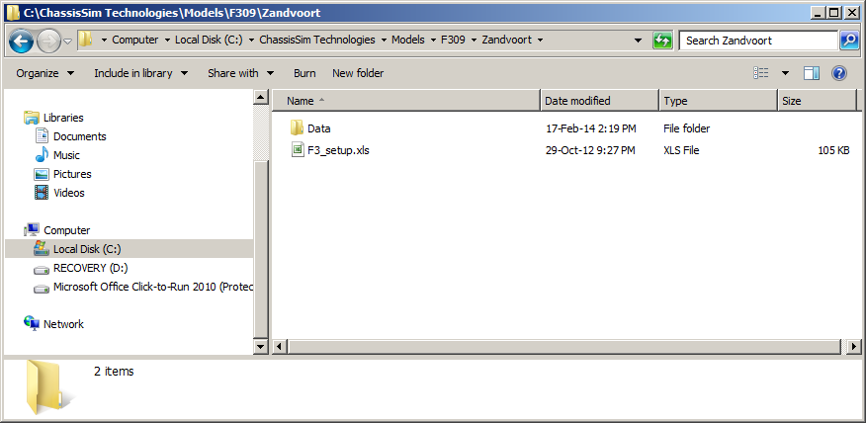

Step – 2 – Setting up ChassisSim

Open up ChassisSim. Once ChassisSim is open go to View->Select units to use. This will display the following dialog.

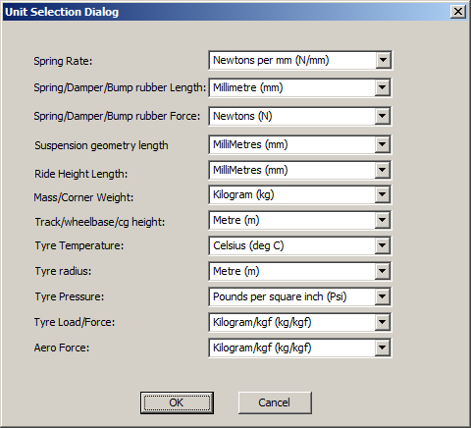

This allows you to configure the input units of ChassisSim for your setup variables. You can toggle between different setup units if required as you will need to do in this tutorial. Also ChassisSim will remember you choice so you don’t have to do it every time.

The next step is to setup the apex cornering algorithm options. To do this click on the Start button in the lower right hand corner of ChassisSim or the menu option Simulate->Simulate. This will bring up the simulate window. Click on Adv Options tab. This will bring up the following dialog,

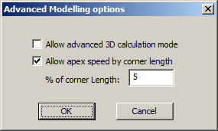

Click on OK and cancel on the simulation window

Step – 3 – Choosing and creating a car model.

ChassisSim comes with a number of well sorted templates. The best way to start a model is to take an existing template and modify it. Don’t be a hero and start from scratch. To do this go to the right hand screen of ChassisSim and select the Dallara F310 template. This process is illustrated below,

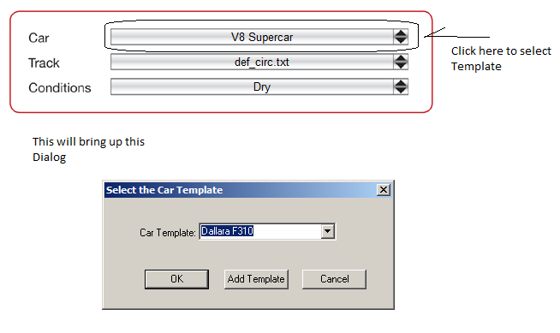

When this is done save this as Dal_F309_example.car in the directory we setup previously. Do this using File->Save As. When done the directory will look like this.

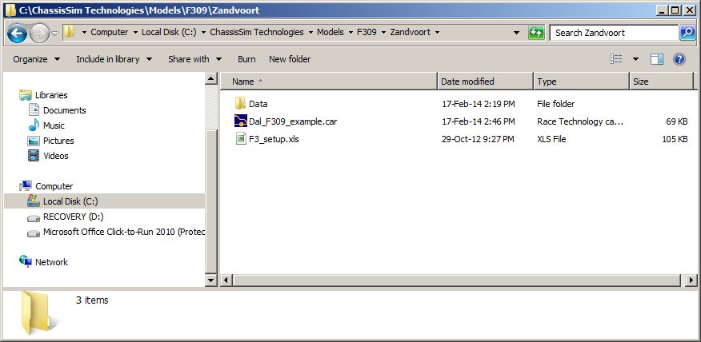

The next step is to enter the setup variables into the model and save as you go. One suggestion is to have the setup sheet and ChassisSim next to each other. This is illustrated below,
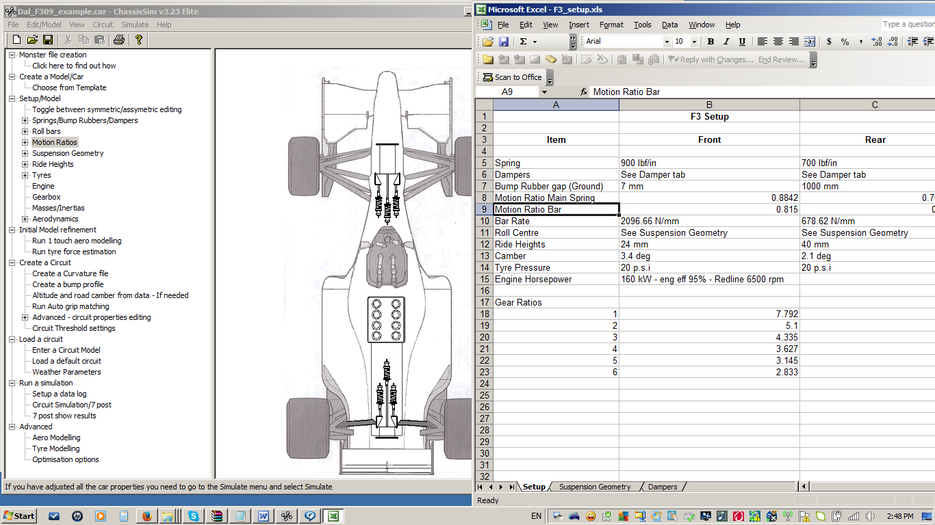

Then all you need to do is to either use the tree structure or car graphic to edit the appropriate component. When using the car graphic simply click on a component you want to modify. Remember save the car file as you go.

Step – 4 – Create the monster file

Our next step is to create the monster file. The format of the file is an ASCII tab delimited file of the data with no headers and footers. The data that is required is,

lap distance (m)
rpm
ay (g)
ax (g)
damp front left (mm)
damp front right (mm)
damper rear left (mm)
damper rear right (mm)
steering (deg) – This is the angle of the tyre as opposed to the steering wheel.
throttle pos (%)
Vehicle speed (km/h)

If you have strains,

Strain Front Left (kgf)
Strain Front Right (kgf)
Strain Rear Left (kgf)
Strain Rear Right (kgf)

These are added at the end of the other listed parameters. What it would look like in a file is shown below,

Without loads,

0 7392.94 -0.03 0.1 4.65 4.87 5.51 5.57 0 100 207.92
1.174 7395.56 -0.03 0.11 5.01 4.58 5.16 4.72 0.03 100 207.99
2.346 7398.33 -0.02 0.11 5.08 4.85 5.98 6.57 0.06 100 208.07
3.52 7401.26 -0.02 0.12 4.83 4.81 10.52 11.16 0.08 100 208.15
4.693 7404.28 -0.02 0.12 3.93 3.96 13.22 13.3 0.09 100 208.24
5.867 7407.27 -0.02 0.12 4.07 3.72 12.74 12.42 0.1 100 208.32
7.042 7410.23 -0.02 0.12 6.22 5.88 13.07 12.63 0.06 100 208.4
8.217 7413.14 -0.03 0.12 5.77 5.69 11.26 11.23 0.02 100 208.49
9.392 7416.04 -0.03 0.12 5.52 5.44 10.26 10.61 -0.01 100 208.57
10.568 7418.92 -0.03 0.11 7.27 6.85 11.73 11.65 -0.03 100 208.65
11.744 7421.78 -0.04 0.11 7.36 6.88 12.43 11.88 -0.03 100 208.73
12.921 7424.61 -0.05 0.11 5.72 5.62 10.39 10.2 -0.01 100 208.81
14.098 7427.42 -0.05 0.11 5 5.05 8.36 8.39 0.01 100 208.89
15.276 7430.27 -0.05 0.11 6.46 6.37 8.75 8.48 0.03 100 208.97
5865.339 7392.94 -0.03 0.1 4.65 4.87 5.51 5.57 0 100 207.92

With loads the file looks like

0 7392.94 -0.03 0.1 4.65 4.87 5.51 5.57 0 100 207.92 166.98 157.86 216.53 202.85
1.22 7392.94 -0.03 0.1 4.65 4.87 5.51 5.57 0 100 207.92 166.98 157.86 216.53 202.85
4.55 7392.94 -0.03 0.1 4.65 4.87 5.51 5.57 0 100 207.92 166.98 157.86 216.53 202.85

Please note the distance vector needs to have at least 2 decimal places. This is very important.

Also for monoshock users for the FL and FR Damper columns copy the front damper movement. So for a monoshock the format will be,

lap distance (m)
rpm
ay (g)
ax (g)
Front damper (mm)
Front damper (mm)
damper rear left (mm)
damper rear right (mm)
steering (deg) – This is the angle of the tyre as opposed to the steering wheel.
throttle pos (%)
Vehicle speed (km/h)

In the Data folder you will find a motec log file. To create a monster file, click on this link,

http://www.chassissim.com/blog/chassissim-news/linking-race-data-to-chassissim-creating-the-monster-file

Follow this video tutorial with the data file dal_f309_act_data.ld provided in the Data folder. Save the monster file in the directory C:\ChassisSim Technologies\Models\F309\Zandvoort.
Please note the following for this data,
- Right hand steer is positive.
- Lateral acceleration is positive for a left hand turn.
- All damper displacements have been zeroed on the ground.

For those of you who don’t have Motec feel free to copy the pre made monster file supplied in the ChassisSim Tutorial folder. Also for those of you with Motec feel free to use this as a sanity check for what you produce.

Step – 5 – Create a curvature and bump profile.

Now that you have a monster file and a car file you need to create a curvature and bump profile. The curvature file is the path the car will follow and the bumps are the road surface profile of the circuit.

To create the curvature file Go to Circuit->Create/Filter Curvature file. This will display the following dialog and set it up as illustrated,

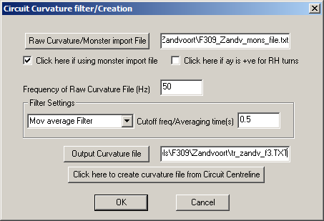

Click on OK. You just created a curvature file. As a sanity check I use Circuit->Edit Variable grip factors to double check I have created the right circuit.

The next step is to create a bump profile. To do this go to Simulate->Bump Profile Modelling. Import the monster file using the monster file import tab. Setup the dialog as shown below,

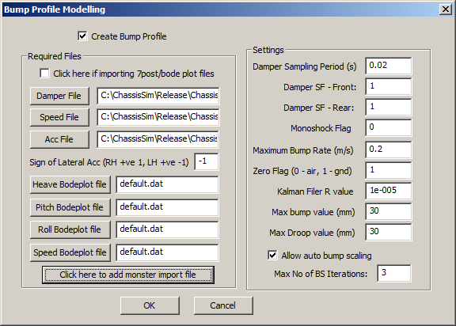

Click on OK and this will start the bump profiling process. This will create a file called bump_profile.dat in the same directory as the car file. As a sanity check open this file with notepad and inspect the values. You should have something that looks like this,

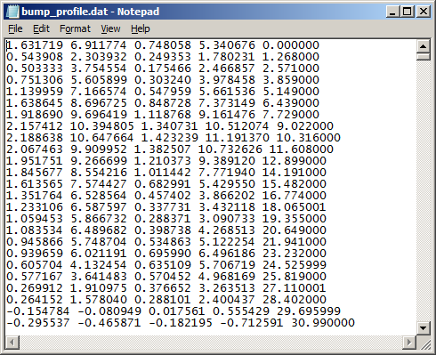

If you have something that looks like this rename the bump profile as bp_zandv_f3.dat. Also please note when using the Auto bump scaling check box please ensure you have the correct sign of the lateral acceleration. The final step is to load this into Circuit->Circuit Data. The dialog will resemble this,

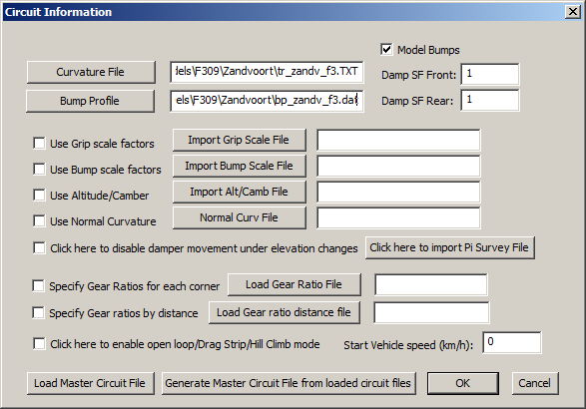

Click on OK.

Step – 6 – Logging and refining your first simulations

To setup a data log for your first simulation go to Simulate->Data Logging options. Fill in the dialog as shown below,

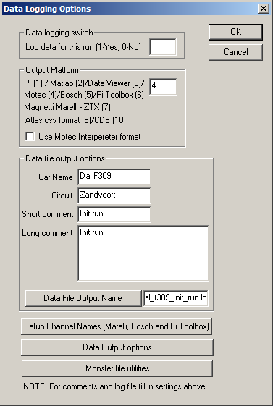

Setup this data file in the directory in C:\ChassisSim Technologies\Models\F309\Zandvoort\Data .

Finally either press the Start button or go to Simulate->Simulate. This will bring up the simulation window. Click on the Start Simulation tab. When the simulation is done you will see the following.

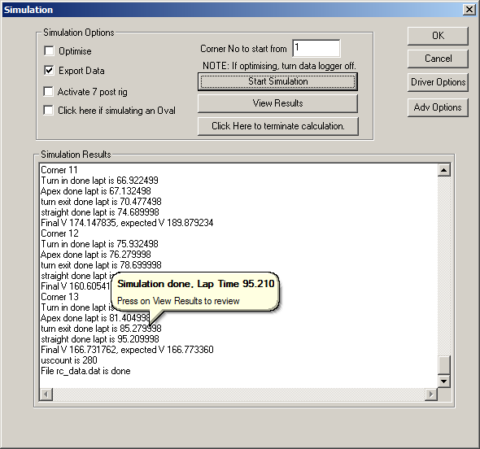

The next step is to overlay this with actual data. This comparison is shown below,

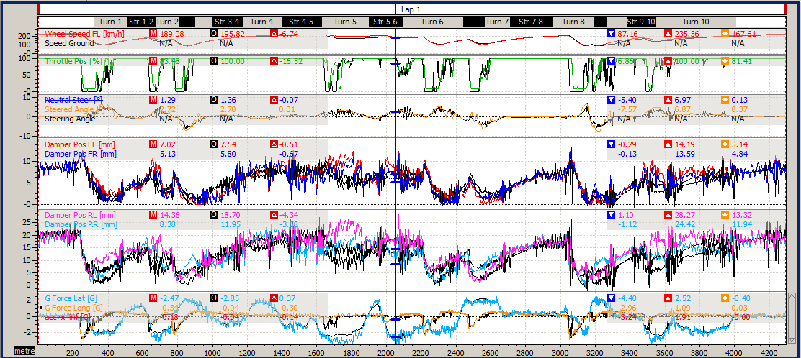

The coloured is actual data, the overlay is black. As can be seen on the straight at equivalent speeds the damper displacements are very similar. This indicates we don’t need to run the 1 touch aero modelling. However while the speed trace is the right shape the cornering speeds are down every where.

We have two options to address this. The first is to run the tyre force estimation. This is covered in the document in the help directory CSim_modelling_in_minutes.pdf. However given this correlation needs only a little tweak the most expedient thing is to increase the grip factor 10% everywhere. To do this go to Tyres and edit the tyre grip factor and increase the value by 10%. The results of this simulation are shown below.

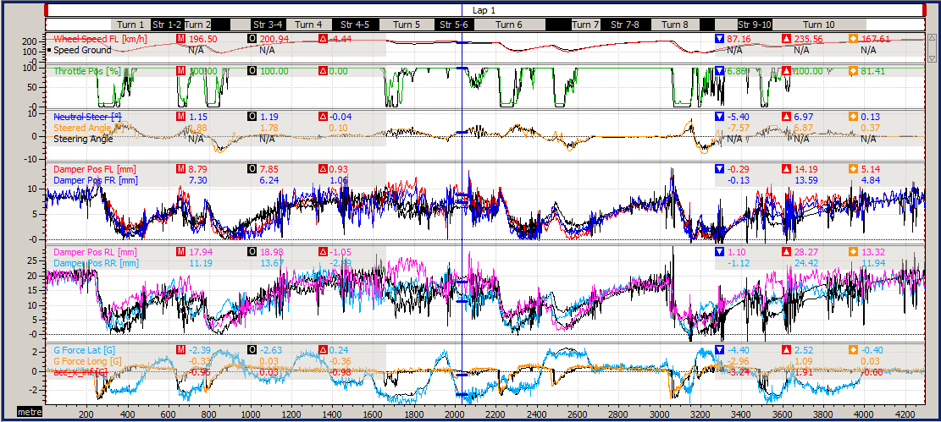

As can be seen the lap time has dropped to 92.6s and the speed traces are much closer.

At this point you have a number of options. The first option is to run the auto grip feature to dial in the corner speeds. The advantage of this approach is it gives you something you can use straight away. When this option was run the lap time was 92.6s however that was because a shift was missed which is very easily rectified. Apart from that the corner speeds where spot on and this model can be used for basic analysis.

The other option and more appropriate option is to refine the vehicle and circuit model. Looking at the rear damper traces there are a bits in the kinematic model (particularly anti squat at the rear) and the aero model that requires modification. Also looking at the steering traces work has to be done on the tyre model. Also this circuit does have altitude and road camber variations that need to be taken into account. If it was me this is the option I would be taking. Long term you will get a much better car model.

Conclusion

As can be seen what was done here was not difficult all we did was to work through a series of simple steps. These steps where,
- Setting up our folders.
- Setting up ChassisSim
- Creating the model from an existing template.
- Creating the curvature and bump profile.
- Running this simulation and comparing to data
- We then refined the model from this point.

Also remember the point of this document is to show you how to orientate yourself to ChassisSim. You still need to work through the quick start guides. Work though these quick start guides in this order.

1) CSim_std_qstart.pdf
2) CSim_monster_file_creation.pdf
3) CSim_modelling_in_minutes.pdf
4) CSim_track_creation.pdf
5) CSim_aero_model_creation.pdf
6) CSim_tyre_model_quick_start_guide.pdf
7) CSim_tyre_modelling_toolbox_guide.pdf
However if you follow this tutorial it will serve as a good reference point as you get going with ChassisSim. Also feel free to use this example to work through the quick start guides.

